EZ Badges Customer Service Application

Back Office Maintenance Notes - Thomas Uyemura

July 17th, 2015

a) Copy latest restricted list ( (Facility Restriction.xls) in 2003 xls format ) to the Customer Service Drive( U: ? S: ) //RV Storage/EZBadges/DataBase

1) Remove blank lines, usually they are on the top.

2) Rename the tab at the bottom from "Kimi" to Sheet1.

3) Be on the lookout for any entries that DON'T have an account number! If there is no account number, it will not be looked up!

b) Copy latest resident list ( (Current BBRD Resident List.xls) in 2003 xls format ) to customer Service Drive( U: ? S: ) //RV Storage/EZBadges/DataBase.

c) Copy latest notes files ( (Group xxxx to x999.xls) )to customer Service Drive( U: ? S: ) //RV Storage/EZBadges/DataBase. This should occur when the “Get Latest Notes” button is pressed. This can be verified by checking the

d) Verify that there is a //RV Storage/EZBadges/DataBase/BadgeChecker_Logger.xls file.

e) The receptionists should hit the "Get Latest Notes" button once in a while. At least once a day.

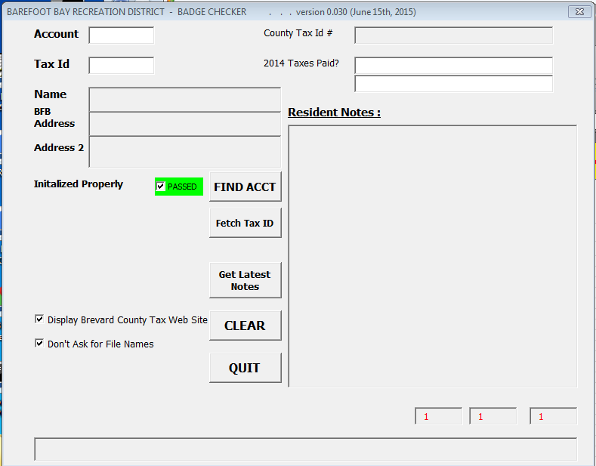

f) Once a year, probably in April, the year needs to roll over. So, in April 2016, we’ll be checking the 2015 tax payments. The two places to change this are here : The second tab, the “Configuration” tab is protected. The password is “audit” in all lowercase. As usual, the password is also located in cell AA1.

